**PROGRESS REPORT**

**Group No: 09**

**Build Me**

**(Web Application for Career Guidance Unit)**

**Industrial Information Technology**

**Department of Science and Technology**

**Uva Wellassa University**

**September 2018**

**GROUP NO: 09**

**Group Members**

|  |  |  |  |  |
| --- | --- | --- | --- | --- |
| **No** | **Name** | **Registration No** | **E-mail** | **Contact No.** |
| **1** | B.D.S.S.Lakshan | UWU/IIT/15/010 | Samithalakshan98@gmail.com | 0756700409 |
| **2** | K.M.M.Kiyas | UWU/IIT/15/025 | kiyaskm1@gmail.com | 0755600904 |
| **3** | H.M.U.P.Rathnakumara | UWU/IIT/15/042 | umani.prathibha95@gmail.com | 0714280920 |
| **4** | W.M.T.C.Wijerathnayake | UWU/IIT/15/058 | chathu.thili5555@gmail.com | 0702164658 |

**Supervisor Details**

|  |  |  |
| --- | --- | --- |
| **Name** | **E-mail** | **Contact No** |
| R.M.I.S.Ranasinghe | iranthi@uwu.ac.lk | 0772683895 |

**Functional and Non-functional requirements**

**Functional-requirements**

* The application shall collaborate the undergraduates and industry through this application
* The application must be able to collect, analyze the data and interpret the final reports related to the surveys that conducted by the career guidance unit
* The application must be able to maintain the data of undergraduates
* The application shall promote and manage the upcoming workshops details
* The application will facilitate enough guides to the entrepreneurs to handle the startups
* The application should be able to store the CVs of undergraduates for future use
* The application should be able to inform the undergraduates about the job opportunities related to their degree programs
* The application should be able to make career appointment

**Non-functional requirements**

**Availability**

This system should be available within 24 hours in every day in the year

**Security**

This system provides a user name and password for each and every user to avoid unauthorized access to this system

**Efficiency**

This automated system can manage this process consuming a minimum amount of time as well as minimum amount of manpower

**Usability**

This system provides interfaces to each and every user to fulfill their tasks in a well- manage and clear manner

**It contains better storage capacity**

This web application capable to store sufficient amount of data of the graduates and an undergraduates

**User Levels and User Roles**

**User Levels**

* System Admin
* General Admin
* Data Entry Operator
* Undergraduates

**User Roles**

**System Admin**

* Login to the system****
* Manage user*

**General Admin**

* Login to the system****
* View the reports
* Accept career appointments*
* View project proposals
* Select project proposals

**Undergraduates**

* Login into the system
* Register in the system*
* Upload and update CVs*
* View site news and upcoming workshop details
* View and response survey
* Download Mentor’s details*
* Calculate GPA*
* Do the self-evaluation*
* Upload project proposals*
* View the gallery and upload creative ideas into “Ketapath Paura”
* Receive twitter messages
* Request an career appointments*

**Data Entry Operator**

* Login to the system
* Analyze survey reports*
* View the reports
* Update site news and upcoming workshop details*
* Upload images into the gallery *
* Upload motivational videos*
* Download project proposals*
* Send information messages*

**System Design Diagrams**

**ER Diagram**

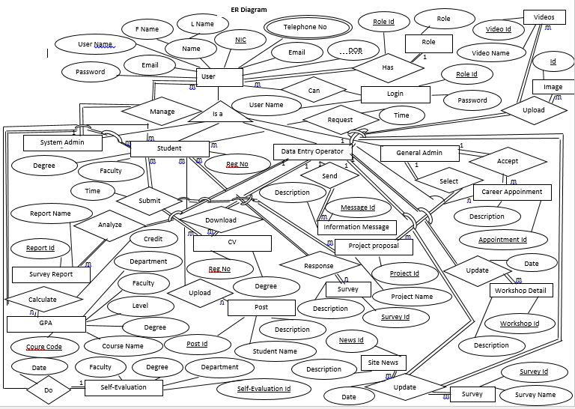

**Data Flow Diagram**

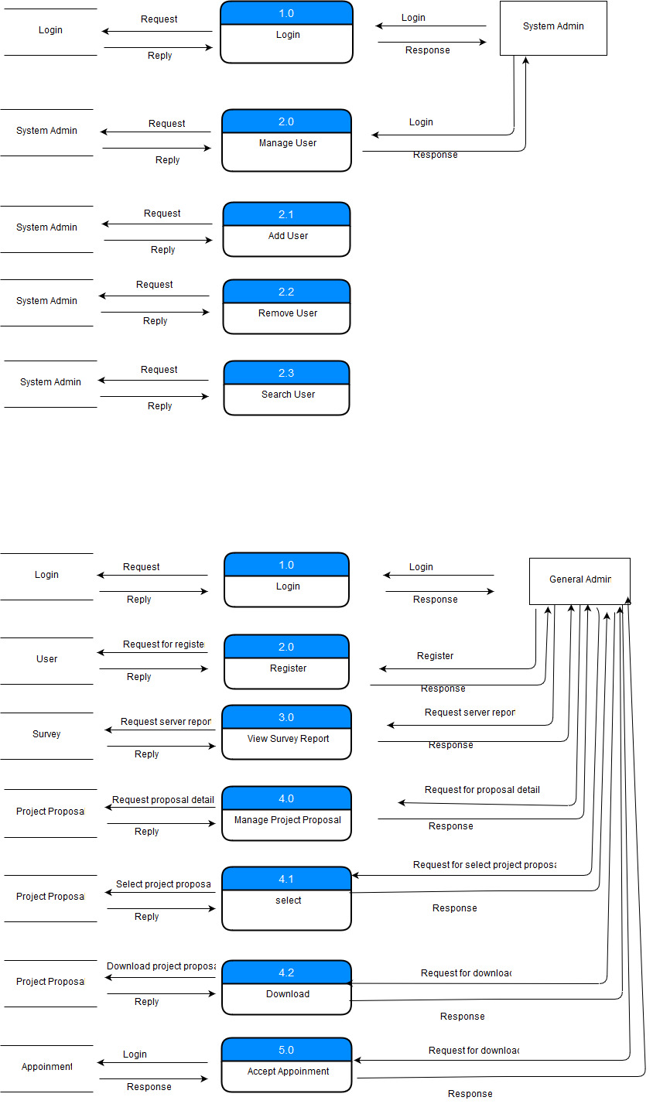

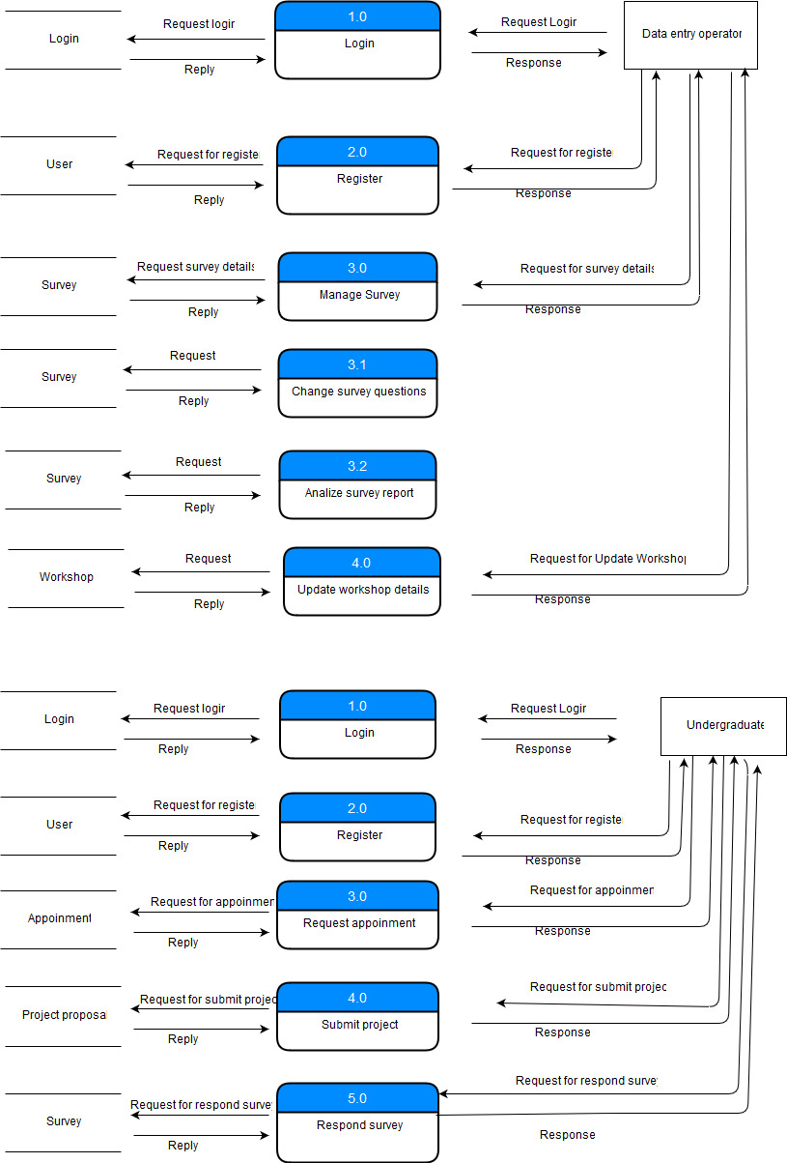

**Usacase Diagram**

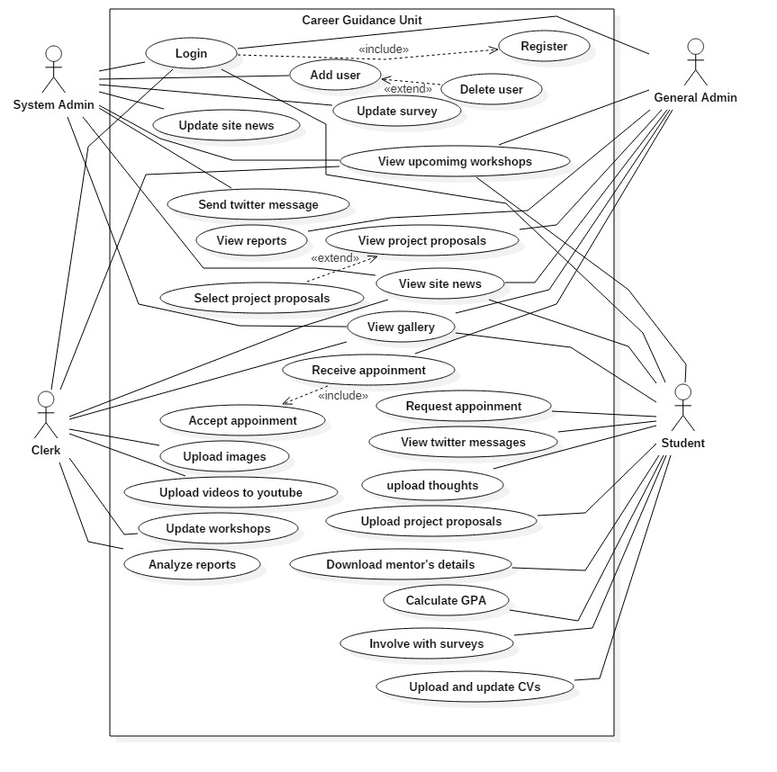

**Class Diagram**

